LAB #06

Generating Sinusoids, Addition of Sinusoids with Variation in Parameters and their Plots, Linear Phase Shift Concept When Dealing with Sum of Sinusoids



Spring 2023

**CSE-301L Signals & Systems Lab**

Submitted by: MUHAMMAD SADEEQ

Registration No.: 21PWCSE2028

Section: C

“On my honor, as a student of the University of Engineering and Technology, I have neither given nor received unauthorized assistance on this academic work”

Submitted to:

Engr. Sumayyea

(7 April 2023)

Department of Computer systems engineering

University of Engineering and Technology, Peshawar

**Task 1**

**Code:**

|  |
| --- |
|  |

**Output:**

>> task1

v = Columns 1 through 8

0.7071 0.0000 -0.7071 -1.0000 -0.7071 -0.0000 0.7071 1.0000

Columns 9 through 10

0.7071 0.0000

**Task 2**

**Code:**

|  |
| --- |
|  |
|  |
|  |
|  |
|  |
|  |
|  |
|  |

**Output:**

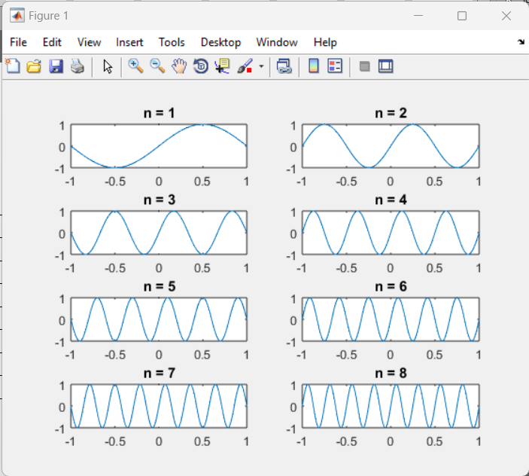

**Task 3**

**Code:**

|  |
| --- |
|  |
|  |
|  |
|  |
|  |
|  |
|  |
|  |
|  |
|  |
|  |
|  |
|  |
|  |
|  |
|  |
|  |
|  |

**Output:**

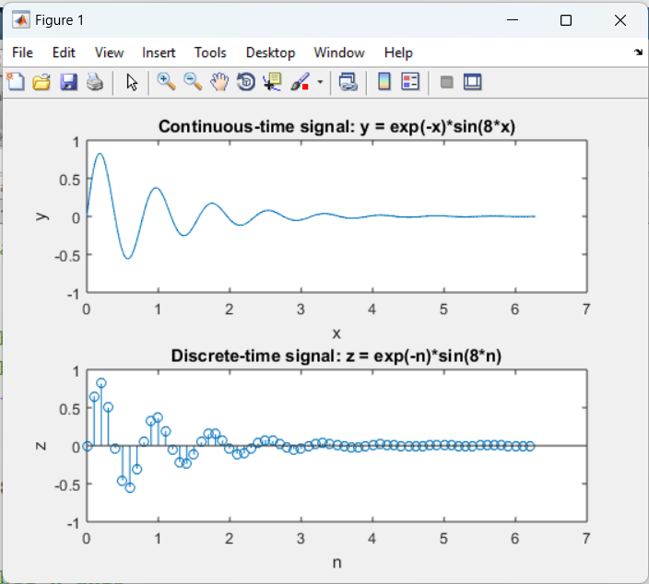

**Task 4**

**Code:**

|  |
| --- |
|  |
|  |
|  |
|  |
|  |
|  |
|  |
|  |
|  |
|  |
|  |
|  |
|  |
|  |
|  |
|  |
|  |
|  |

**Output:**

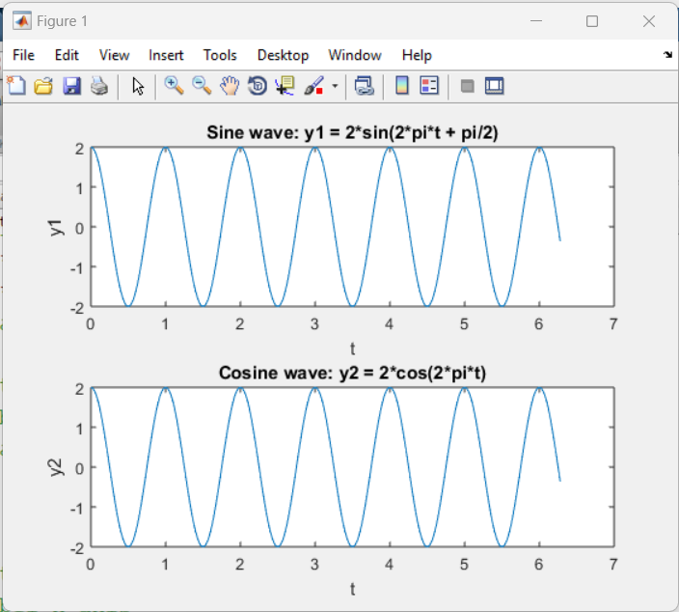

**Task 5**

**Code:**

|  |
| --- |
|  |
|  |
|  |
|  |
|  |
|  |
|  |
|  |
|  |
|  |
|  |
|  |
|  |
|  |
|  |
|  |
|  |
|  |

**Output:**

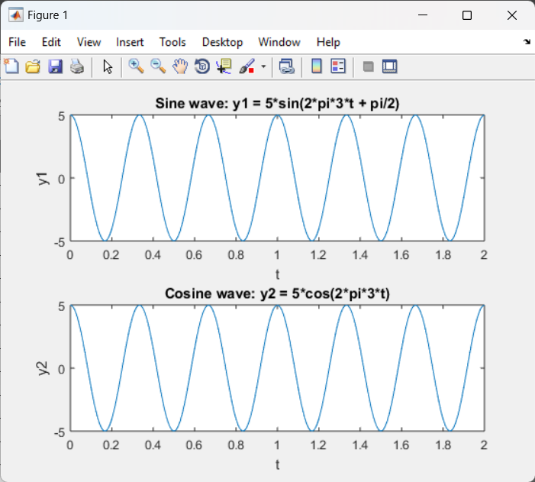

**Task 6**

**Code:**

|  |
| --- |
|  |
|  |
|  |
|  |
|  |
|  |
|  |
|  |
|  |
|  |
|  |
|  |
|  |
|  |
|  |
|  |
|  |
|  |
|  |
|  |
|  |
|  |
|  |
|  |
|  |
|  |
|  |
|  |
|  |
|  |

**Output:**

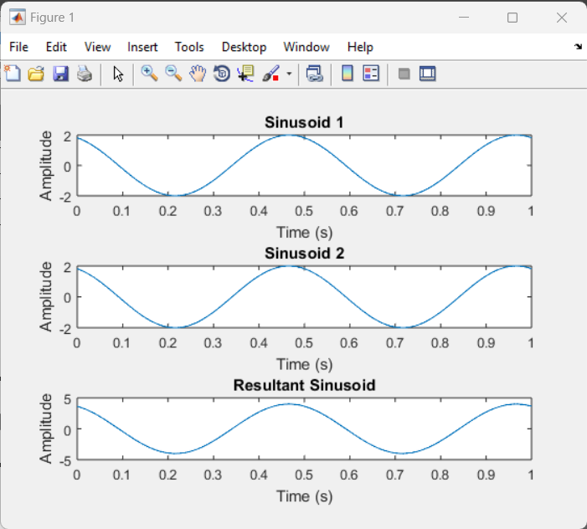

**Task 7**

**Code:**

|  |
| --- |
|  |
|  |
|  |
|  |
|  |
|  |
|  |
|  |
|  |
|  |
|  |
|  |
|  |
|  |
|  |
|  |
|  |
|  |
|  |
|  |
|  |
|  |
|  |
|  |
|  |
|  |
|  |
|  |
|  |
|  |
|  |
|  |
|  |
|  |
|  |

**Output:**

>> task7

Enter the number of sinusoids: 5

Enter the frequency of the sinusoids (in Hz): 5

Enter the phase of the sinusoids (in radians): 5

Enter the amplitude of sinusoid 1: 5

Enter the amplitude of sinusoid 2: 5

Enter the amplitude of sinusoid 3: 5

Enter the amplitude of sinusoid 4: 5

Enter the amplitude of sinusoid 5: 5

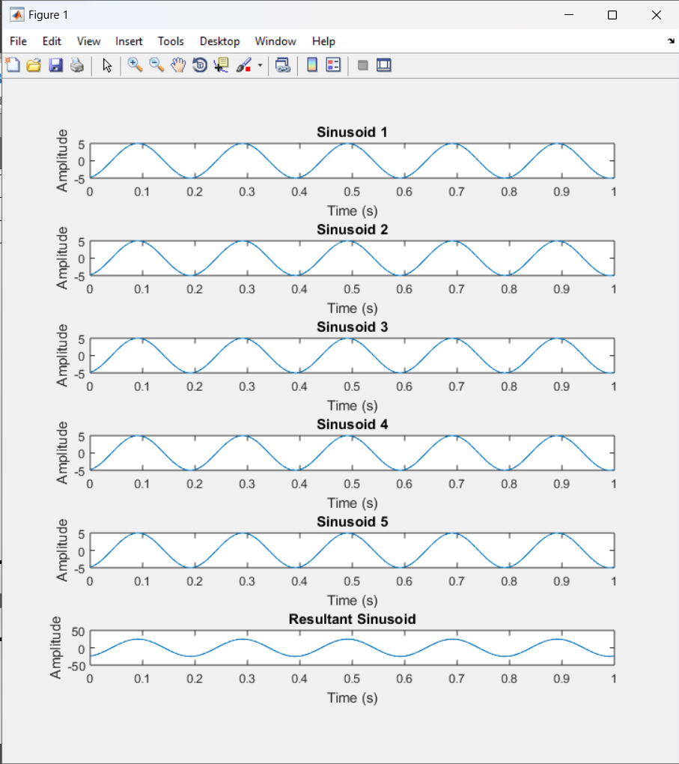

**Task 8**

**Code:**

|  |
| --- |
|  |
|  |
|  |
|  |
|  |
|  |
|  |
|  |
|  |
|  |
|  |
|  |
|  |
|  |
|  |
|  |
|  |
|  |
|  |
|  |
|  |
|  |
|  |
|  |
|  |
|  |
|  |
|  |
|  |
|  |
|  |
|  |
|  |
|  |
|  |
|  |

**Output:**

>> task8

Enter the number of sinusoids: 2

Enter the amplitude of the sinusoids: 2

Enter the phase of the sinusoids (in radians): 2

Enter the frequency of sinusoid 1 (in Hz): 2

Enter the frequency of sinusoid 2 (in Hz): 2

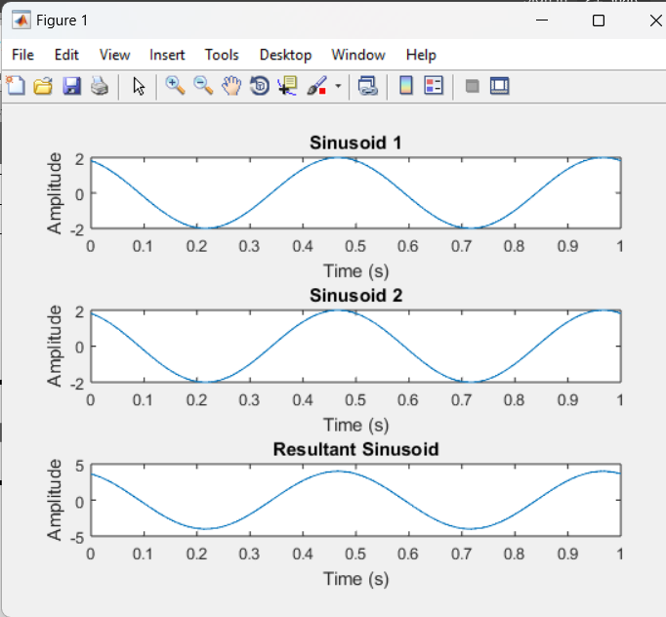

**Task 9**

**Code:**

|  |
| --- |
|  |
|  |
|  |
|  |
|  |
|  |
|  |
|  |
|  |
|  |
|  |
|  |
|  |
|  |
|  |
|  |
|  |
|  |
|  |
|  |
|  |
|  |
|  |
|  |
|  |
|  |
|  |
|  |
|  |
|  |
|  |
|  |
|  |
|  |
|  |
|  |

**Output:**

>> task9

Enter the number of sinusoids: 2

Enter the amplitude of the sinusoids: 2

Enter the frequency of the sinusoids (in Hz): 2

Enter the phase of sinusoid 1 (in radians): 2

Enter the phase of sinusoid 2 (in radians): 2

